The Bishop in Europe:
The Right Reverend Dr. Robert Innes

19 October 2021

Bishop’s Advent Appeal for European Climate Disaster Relief 2021

Climate change is probably the biggest single issue facing humanity at present and into the future. When I speak to Anglican colleagues from around the world, I hear of its impacts in everything from threatened islands in Polynesia to desertification in sub-Saharan Africa. But this last summer, we have been forcibly reminded that climate change is a global phenomenon that visits our own doorstep in Europe: fires have taken hold in Greece, Spain and Turkey; there has been severe and fatal flooding in Germany, Belgium and the Netherlands. Our chaplain in Liège, Revd Guy Diakiese, was among those pushing water and mud out of the living-rooms of neighbours.

The root causes of climate change are now generally acknowledged to be the increase in greenhouse gases generated mainly by the human burning of carbon. There is pressure worldwide to reduce use of fossil views and stabilise temperature rises, and this is what COP26 in Glasgow is about. But as well as addressing the causes we also need to address the effects of rising temperature, as seen in more and more extreme weather events. Very high rates of rainfall and very high temperatures have a devastating impact on the wellbeing of people and property, as we have seen in our corner of the world. The image is of the town of Bad Neuenahr in the Rhineland.

So my Advent Appeal this year will be focused on assisting agencies that are working in these parts of Europe, as they bring support to those who are affected by man-made climate change.

Many of us will know the work of Caritas International, the Roman Catholic agency that sustains many varieties of Christian relief and support across the world; their national agencies in Spain and Italy will assist with disaster relief.

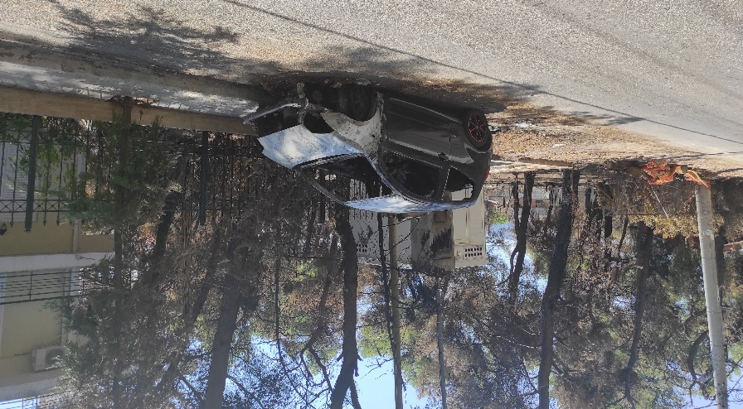
Apostoli is an agency of the Orthodox Archdiocese of Athens. They want to help with the schooling of children displaced by the fires in Greece. Our picture shows the island of Evia, the first to be impacted. Thank you to Revd Christine Saccali, from the Athens chaplaincy, who was nearby.

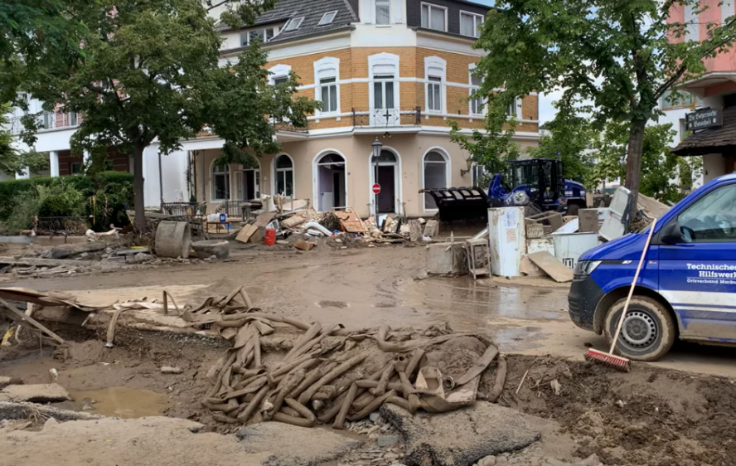
The “Churchhelp” arm of the Evangelical Church in Germany was amongst the first on the scene in the clearing-up after the terrible flooding in that country. This is from a documentary of their work in Bad Neuenahr, in the Rhineland-Palatinate.

“First Hope” is a Protestant agency working in Turkey to support those displaced by conflict, migration and (this summer) the forest fires. Imaginatively, they provide “hygiene trailers”, so that those who no longer have a home have places to wash, shower and clean clothes.

Funds raised will be divided between the different agencies. As usual, we invite each chaplaincy to make its own arrangements for collection of money towards the Bishop’s Appeal and then for the local church treasurer to forward collections to Nick Wraight at the diocesan office (see below). Please remember to send an email to nick.wraight@churchofengland.org alerting him to the kind donation.

This is a very practical way in which the whole diocese can contribute towards the needs of those who have become the most vulnerable people on our continent. Please do encourage your people to give generously.

Yours sincerely,
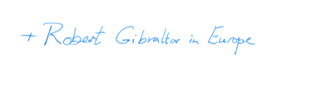
+Robert Gibraltar in Europe

How you can donate to the Bishop in Europe’s Advent Appeal 2021:

By cheque made out to:
Diocese in Europe (Advent Appeal 2021)

send to :
Nick Wraight
Diocese in Europe
14 Tufton Street
By bank transfer to:
Account number: 40317039
Sort code: 20-06-13
IBAN: GB16 BUKB 2006 1340 3170 39
Swiftbic: BUKBGB22

London SW1P 3QZ

On the Diocese in Europe Just Giving page:
https://www.justgiving.com/diocese-ineurope

