The Bishop in Europe:
The Right Reverend Dr. Robert Innes

Dear Brothers and Sisters in Christ,

BISHOP’S LENT APPEAL 2019

Mental Health and Livelihoods Support for the Vulnerable in Greece

I send you this appeal as we begin to prepare our hearts and minds for the beginning of Lent in three weeks’ time.

Natural as well as man-made disasters in our world bring hurt and heartbreak to all those affected. They remind us of the fragility of our human existence, wherever we live. Where natural disaster has occurred, there is physical suffering: the tragedy of lives lost, or the pain of families, homes and livelihoods devastated. But the wounds are also psychological. And they frequently do not manifest themselves immediately, but later on. This is especially true for the vulnerable and applies particularly to children.

In July 2018, the resort village of Mati witnessed Greece’s worst ever forest fires. The death toll reached 100, over 200 people injured, and over 700 evacuated from their homes. To these numbers, we should add the number suffering from Post-Traumatic Stress Disorder (PTSD) and other psychological after-effects.

An Athens-based organisation called Hestia Hellas is providing a vulnerable community with sustainable tools and a skill set necessary to participate in daily life and thrive in times of difficulties. Greece is facing multiple challenges including an economic crisis, an influx of refugees and migrants and the devastating fires that have deprived many families from housing and jobs. Hestia Hellas is dedicated to offering psycho-social support services, Child Friendly Space, jobs and life skills support, and food distribution to those in need.

In a video, our chaplain in Athens, Fr. Leonard Doolan and Lauraine Velez, Co-Founder and Director of Hestia Hellas speak about the project. This can be viewed at:

https://www.youtube.com/watch?v=amsICtNva1s&feature=youtu.be

There will be an Appeal launch on the Diocesan website at https://europe.anglican.org/bishops-appeals/bishops-appeals, followed by regular updates on the website, and our social media. Do keep an eye out for these. And please do consider how you can support my appeal. As usual, you can give money to this appeal through your church treasurer, who will forward money to the diocesan office.

Hestia Hellas express in their own words why this cause is so important and how we can help:

“The Greeks, who were recent refugees themselves, know what it’s like to be forced from their homes. They have a special word in their culture, Filoxenia, which the literal translation means “friend to the foreigner”. Greeks, like the many refugees and migrants we see today need our help to regain parts of themselves that they’ve lost through devastating experiences. With the continued support of the Anglican Church, and their generosity, we can serve the Greek and refugee populations side by side.”

I wish you a holy and spiritually fulfilling Lent.

With every blessing,

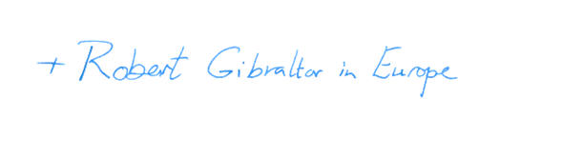
+Robert Gibraltar in Europe

